**SE 4485: Software Engineering Projects**

Spring 2024

**Detailed Design Documentation**

|  |  |
| --- | --- |
| Group Number | 10 |
| Project Title | Internet Research Assistant |
| Sponsoring Company | The Fellows Consulting Group |
| Sponsor | Jeff |
| Students | Bakr Alkayali  Chloe Pascual  Vi Le  Ikraam Rahman  Mohammad Chauhan |

ABSTRACT

The detailed design document is a comprehensive outline of the design of our internet research assistant. It illustrates the ideal visual UI of the website and focuses on how the interface interacts with the user. Moreover, the static model class diagrams and dynamic model sequence diagram depicted also show all the other design considerations such as the relationships and interactions between the AI tools, database, logger, etc and the previously mentioned user facing interface. The GUI presented is a Figma mockup which will be translated to the frontend of the project implementation to the extent possible. In the latter half the

TABLE OF CONTENTS

LIST OF FIGURES

LIST OF TABLES

INTRODUCTION

* The detailed design documentation provides a complete description of the system and how it was developed. This document mostly goes into the intricacies of the system’s architecture, functionality, and underlying technologies.
* purpose and scope of the document
  + The document
* description of the structure of the document

GUI (Graphical User Interface) Design

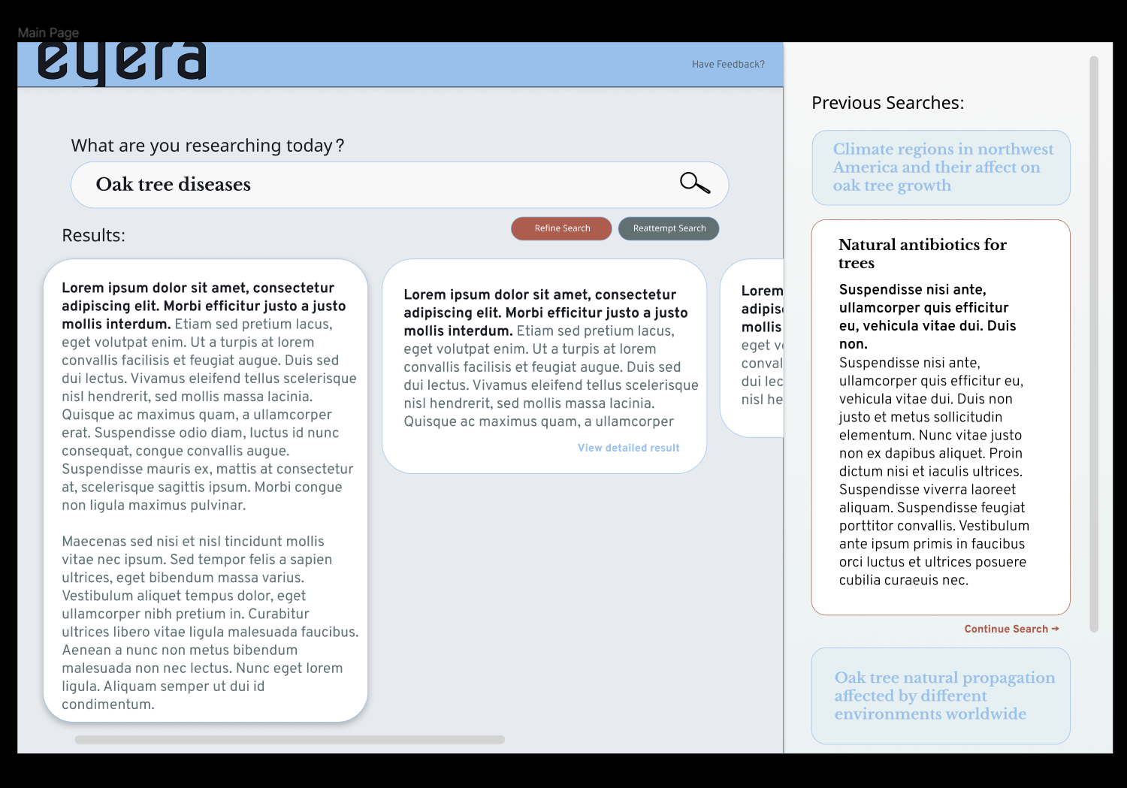Main Graphical User Interface of Eyera

STATIC MODEL CLASS DIAGRAMS

* captured in Rose (other tools are also allowed)

DYNAMIC MODEL SEQUENCE DIAGRAMS (Vi – let me know if any change needed)

* captured in Rose (other tools are also allowed)

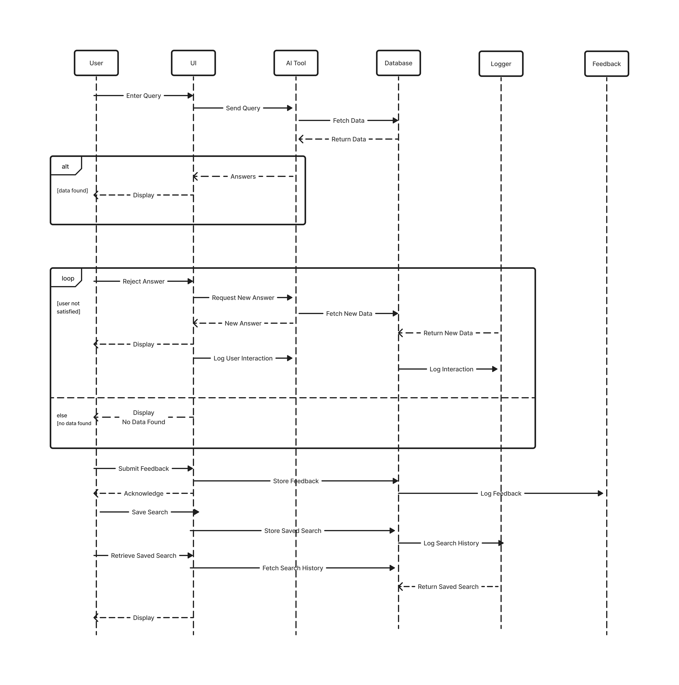

RATIONALE FOR YOUR DETAILED DESIGN MODEL

TRACEABILITY FROM REQUIREMENTS TO DETAILED DESIGN MODEL

FRs

|  |  |  |  |
| --- | --- | --- | --- |
| Requirement ID | Requirement Description | Design Element | Design Description |
| FR1 | Perform Search/Enter Search Query | 1. SearchController 2. SearchService 3. SearchQueryValidator 4. SearchResultBuilder 5. SearchRepository 6. SearchResult | 1. Handles UI requests to initiate a search. 2. Implements the logic to process and execute a search. 3. Validates the user input against search criteria. 4. Constructs the search results to be returned to the UI. 5. Interacts with the database to fetch search results. 6. Represents the data of an individual search result |
| FR2 |  |  |  |
| FR3 |  |  |  |
| FR4 |  |  |  |
| FR5 |  |  |  |
| FR6 |  |  |  |
| FR7 |  |  |  |
| FR8 |  |  |  |
| FR9 |  |  |  |
| FR10 |  |  |  |

EVIDENCE THE DESIGN MODEL HAS BEEN PLACED UNDER CONFIGURATION MANAGEMENT

1. Name of the CM tool: GitHub
2. Version number of before:
3. Version number after:
4. Difference between the two:
5. Review of each change:
   1. Before: Added Standards, References, formatted document outline, added GUI, added partial traceability table, added dynamic model diagram.
   2. After:
6. Other info:

ENGINEERING STANDARDS AND MULTIPLE CONSTRAINTS

* IEEE Std 1016-1998-(Revision-2009): Software Design
* ISO/IEC 12207:2017: Systems and software engineering – Software life cycle processes.
* ISO/IEC 15288:2023: Systems and software engineering – System life cycle process.
* ISO/IEC 29148:2018: Systems and software engineering – Life cycle processes – Requirements engineering.
* IEEE Std 830-1998: IEEE Recommended Practice for Software Requirements Specifications.

ADDITIONAL REFERENCES

* Boehm, B., 1988: A Spiral Model of Software Development and Enhancement. ACM SIGSOFT Software Engineering Notes.
* Cockburn, A., 2000: Writing Effective Use Cases. Addison-Wesley.
* Sommerville, l., 2015: Software Engineering. 10th Edition, Addison-Wesley.
* Martin, R.C., 2003: Agile Software Deveolpment: Principles, Patterns, and Practices. PRentice Hall.
* Gamma, E., Helm, R., Johnson. R., Vlissides, J., 1994: Design Patterns: Elements of Reusable Object-Oriented Software. Addison-Wesley.